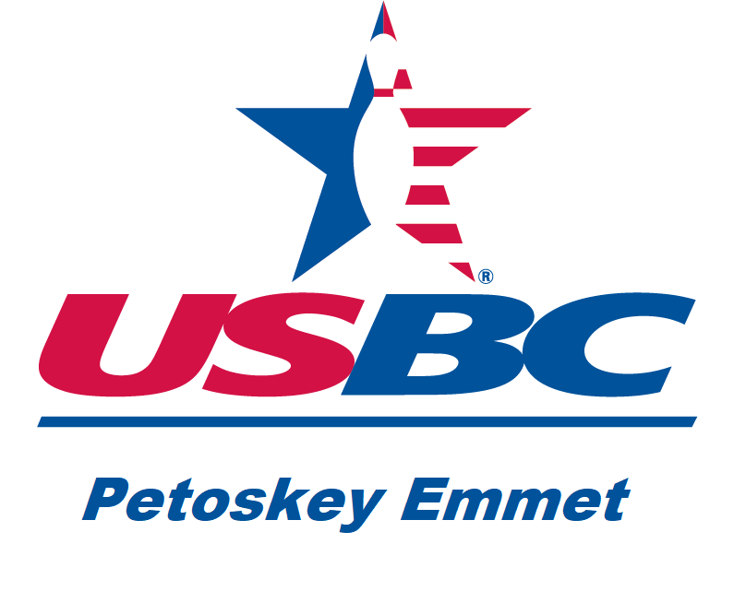
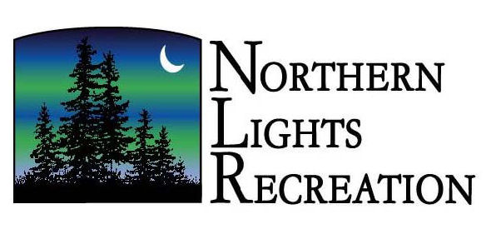
PETOSKEY YOUTH BOWLING
INVITES

All BOYS & GIRLS (Grades 4-12) (School District or Skill Level Does Not Matter)

Northern Lights Recreation, Harbor Springs
Monday Evenings 5:20 p.m. – 7:30 p.m.
(2-10-week sessions)
Team Bowling Begins
Monday September 18, 2023 through December 11, 2023
(High School Team Members, only finish November 27, 2024, begin again March 4, 2024 Grades 9-12)
2nd Session January 8, 2024 through March 18, 2024

Warm-ups begin at 5:20 p.m. Sharp!
$10.00/week Includes bowling and shoes for 3-games
(One-time fee of $20 due first week for sanction fee and year-end banquet)
Bowl for awards, weekly prizes, or just for fun!

Grab your friends and make a 4-PERSON team (BOYS, GIRLS, OR MIXED) or we will help you find a team
Coaching available (dress codes/rules will be enforced)

Sign-up/Organizational Meeting: Monday August 28, 2023, 6:00 p.m. at Northern Lights.

Contact: Deb Hamlin, PHS Bowling Coach at hamlin3@sbcglobal.net or 231-203-3608 with any questions.

Please call/confirm sign-up, even if you have bowled with us in the past!

