Logging into Website Admin Panel
- Admin Panel: http://stephenson.k12.mi.us/admin  - Login using username / password you have been given. | 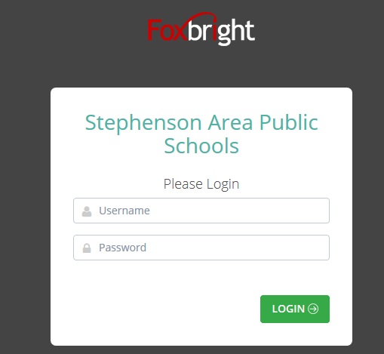

After Logging in you will be on the Admin Panel Home Page
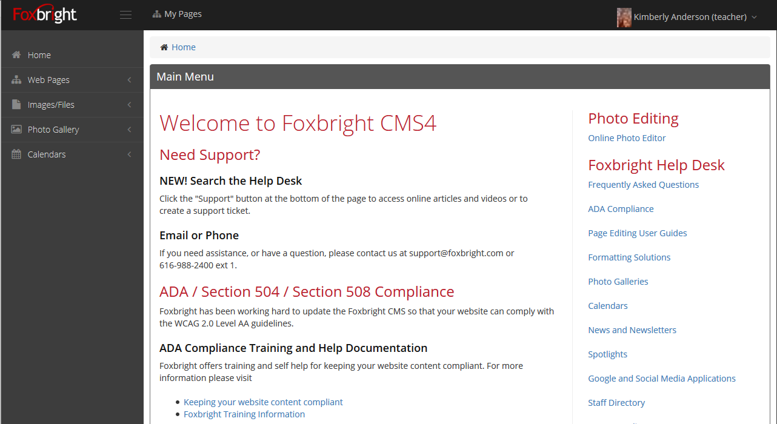

Please note that in the right column is all the help documentation. You will want to use the:
- Page Editing User Guides
- Calendars
- Photo Galleries

Update Contact Information including your photo
Click on your name in the upper right corner and select “My Information”.
- Can update your password
- Update your contact information including
  - Name
  - Phone
  - Extension
  - Email
  - Photo

Edit Teacher Pages & Publish
Select the “My Pages” to access your teacher website.

Adding / Editing Page Content
- From Page Tree, click on Page Name or select Gear and Edit
- “Preview” version of page will be shown with red boxes around content blocks.
- Hover or click on the block and select “Edit”
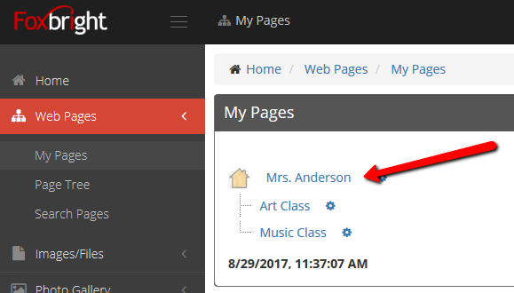

Rich Text Editing
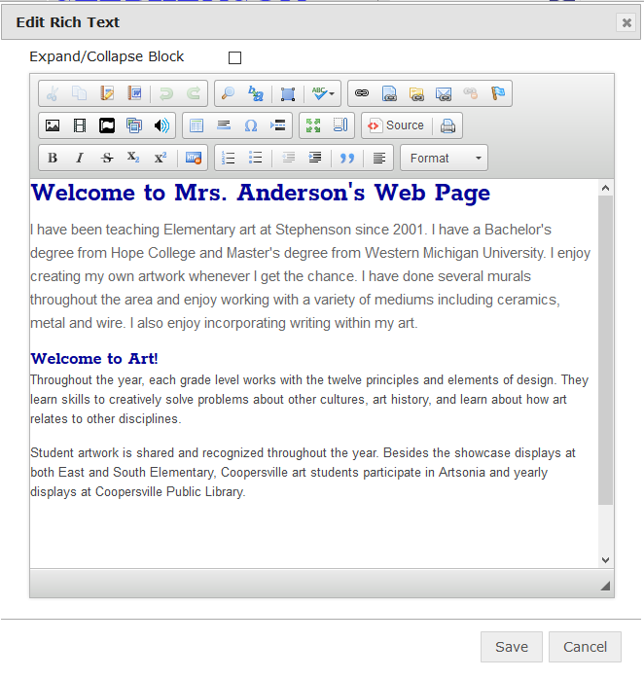
- Inserting Content from WORD (top row 4th icon)
- Use the Paste from Word option to paste in content to retain formatting
- Text Formatting - bottom row of editor icons
Hint: Enter – paragraph break – extra white space between lines
Hint: Shift-Enter – line break – normal white space between lines

Adding Links – located on top row to right
- Links to other websites
- Links to files or pictures
- Links to pages on your website

Note: Use link text that makes sense even when out of context

Inserting Pictures (1st icon on 2nd row)
- Upload / Insert the picture on you page

Publishing Content
- Always “Preview” your page before Publishing
- Revert to Published

Add more Pages to your Teacher Website
- From “My Pages”, select the gear next to your home page (or another page) and select “Add Page”
  - Enter a page name
  - Tab through the fields to populate each field
  - Scroll down to “save” the page
- You can now edit the page

Add a Classroom Calendar

Create a Calendar
From the Side Menu, select “Add Calendar” so you can create a new calendar.
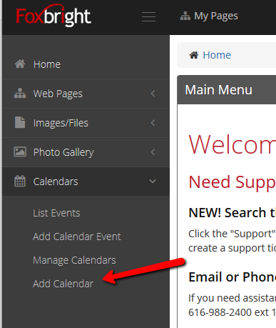
  - Hint: Include your initials or name in your calendar name.

Add your calendar to your website page
- Select “My Pages”
- Edit your “Website Page”
- Add a Block where you want to add the calendar
  - Select “Mini Calendar”, “Upcoming Events” or “Foxbright Multi-Agenda Calendar” as the block type
  - Select “Add Block”
- Now “pick” your calendar to show and finish configuring any of the other options
- Save the block.

Add Events to your calendar
To add events to your calendar, select “Add Calendar Event” from the Calendars selection menu
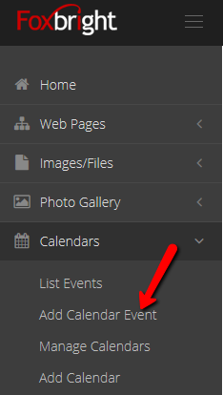

- Select Your Calendar from the drop list
- Enter the Event Title
- Select the Event Date
  - (you can enter a time as well)
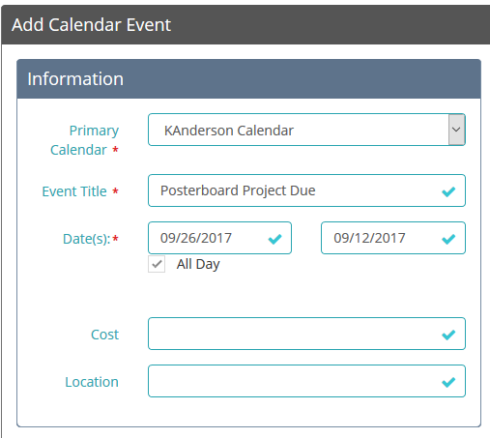
- Use the Event Description to include details about the event
