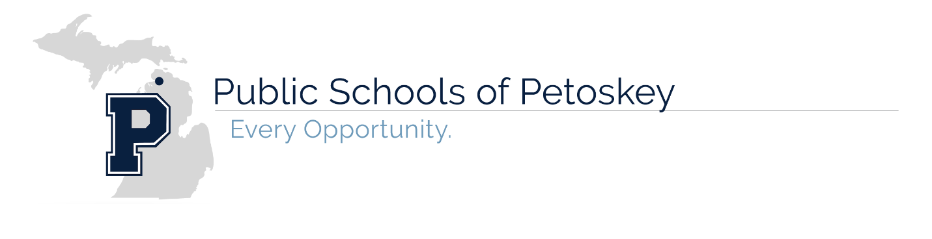

Food Service Charging Guidelines

*** A milk without a meal and a la carte items cannot be charged to your child’s account. No exceptions.
Charging refers to any time a student does not have enough funds to cover the cost of a meal at the point of sale. Charges for meals are permitted for students who occasionally forget their funds up to a MAXIMUM of the dollar equivalent of:
Elementary, grades K - 5th - 2 lunches or $5.50
Secondary, grades 6th - 12th – 2 lunches or $6.00
Reduced students – 4 lunches or $1.60

Once a student reaches the charge limit, the Public Schools of Petoskey will not let a child go hungry and will offer a cheese sandwich, fresh fruit, fresh vegetables and a milk. This alternate meal will be charged to your child’s account, as the meal is not cost free to the district.

The charging policy is for all students, whether they are free, reduced or full pay. All accounts have been reviewed and the amount owed is from one of the following:
- Charges are from before your child was approved for free or reduced meals
  - The State of Michigan does not allow us to remove those charges or retro the benefits to your child’s account
  - It is your responsibility to pay for those meals purchased by your child before your application was submitted and processed
- Charges are from MILK purchases when your child brought in a cold lunch from home
  - A milk without a meal is $ .45 for all free, reduced and full pay students
- Charges are from an oversight on your part for payment
  - Please contact me if you need to set up a payment plan

While we do not want to lose your child eating breakfast and lunch with us, we cannot continue to serve meals, a la carte milk or a la carte items without funds on account to pay for these items. Please make sure you have funds available on your child's account so we can allow your child to purchase a la carte items, including a milk, when a cold lunch is brought from home. Please make CHECKS PAYABLE to: Petoskey Food Service and mail to: 1500 Hill Street, Petoskey, MI 49770.

Notifying Parents of Low Funds
- BEST METHOD… eFunds for schools allows parents to monitor their child’s lunch account and make food service payments online. Families set up and maintain their own login, password and payment preferences.
You can access the eFunds site by going to:
https://eps.mvpbanking.com/cgi-bin/efs/login.pl?access=55514

Balance Reminder: Select “Notifications” from the home page. Select “Advisory Services” and “Low Meal Balance”. Add in your Minimum Balance and click the box for Notice. You will receive an email notification when your child’s account reaches the minimum balance you set. This will allow you to replenish your child’s account before the account goes into the negative.
- Negative balance notices will be sent home with your child (Elementary, K – 5th) in their weekly folders as a reminder to replenish your child’s meal account with funds owed and additional funds that will be needed for future meals.
  - This is a four-step process and has room for errors. Printing, delivery to teacher mailboxes, teacher distribution into student folders and student carrying home folder for parent review.
  - The best method for you to receive balance notices is by creating an account with eFunds.
- Negative balances will be mailed home to secondary students (6th – 12th) once per month or more frequently depending on the amount owed.
- Negative balance reminders will be verbally given to secondary students (6th – 12th) at the register once the student account reaches a positive $5.00 and until funds are deposited on the account.
- If time permits, a food service employee will notify parents by phone, when the student’s lunch account has reached the maximum limit of allowable charges. Parents will be informed that funds are needed OR a packed lunch will need to be brought from home the next day.
  - If funds or a lunch are not brought the next day, your child will be offered the alternate meal.
- At any time, the food service director will add a note to your child’s account and discontinue meals to your child if the maximum limit of allowable charges has been abused. This will take place after phone calls have been attempted with no response from the parents.

Charging will not be allowed at the end of the school year.
- Elementary students, (K – 5th) no charging allowed starting the 3rd week of May
- Secondary students, (6th – 12th) no charging allowed starting May 1st
- Graduating seniors (12th) no charging allowed starting April 1st

Additional Guidelines
The District will not require students with negative balances to:
- Wear a wristband, handstamp, or other form of identifier that they have a negative balance.
- Perform chores or other work duties in order to fulfil a negative balance
- Dispose of a meal after it has been served.

Furthermore, the District will not:
- Directly communicate with a student about a negative balance unless the District has unsuccessfully attempted to contact the student’s parent or legal guardian through telephone, mail, and e-mail.
- Discuss a negative balance with a student in the presence of other students.

Unpaid meal charges will be carried over at the end of the school year and into the next school year.
We will follow the updated charging policy the first day of school.

Please e-mail Beth Kavanaugh at Kavanaugh.ba.u@northmen.org or call (231)348-2183 with any questions.

