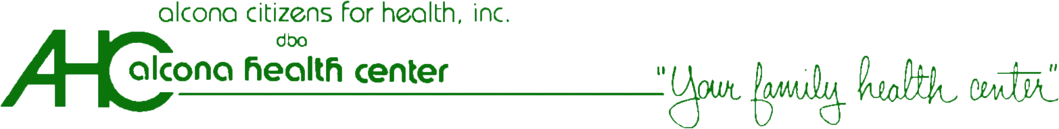

Authorization to Share Health Information

__________________________________________________________________________________________________
Printed Name of Person Whose Information is Being Requested Date of Birth

__________________________________________________________________________________________________
Present address

I authorize and request the Alcona Health Center to obtain or release the following confidential health information contained in my medical records including information about:
- Behavioral and mental health services including referrals and treatment for alcohol and substance abuse disorder
- Communicable diseases and infections, such as tuberculosis ("TB"), sexually transmitted diseases, hepatitis B, Human Immunodeficiency Virus (HIV Infection, Acquired Immunodeficiency Syndrome (AIDS) or AIDS Related Complex (ARC), or other information as described below:
__________________________________________________________________________________________________
Please □ get information from: OR □ release the above information to:

Petoskey High School 231-348-2160
________________________________________________________ ___________________________________
Name Telephone Number
1500 Hill Street Petoskey, MI 49770
________________________________________________________ _______________________________
Address City, State Zip Code

Format to be used: □ Hard Copy □ Verbal

By signing this form I understand:
- My information may be shared among each agency and person listed above
- My information will be shared to help diagnose, treat, manage and pay for my health needs
- My consent is voluntary and will not affect my ability to obtain mental health or medical treatment, payment for medical treatment, health insurance or benefits
- My health information may be shared electronically
- This form does not affect the sharing of my physical health information for purposes of treatment, payment, or health care operations or as otherwise allowed by law
- The sharing of my health information will follow state and federal laws and regulations
- This form does not give my consent to share psychotherapy notes as defined by federal law
- I can withdraw my consent at any time; however any information shared with or in reliance upon my consent cannot be taken back
- I am the client or am authorized to act on behalf of the client and can have a copy of this form

Time Period to be covered: _________________________ Consent Expires on: ____________________________
(If expiration date is left bland or is longer than one year, the consent will expire 1 year from the signature date.)
I have read this form or have had it read to me. I have had my questions about this form answered.

__________________________________________________________________________________________________
Client (or responsible representative) Signature Date

____________________________________________________________________________________________________________
Print name if responsible representative Authority/Relationship to Client

__________________________________________________________________________________________________________________________________________Witness Signature Date

