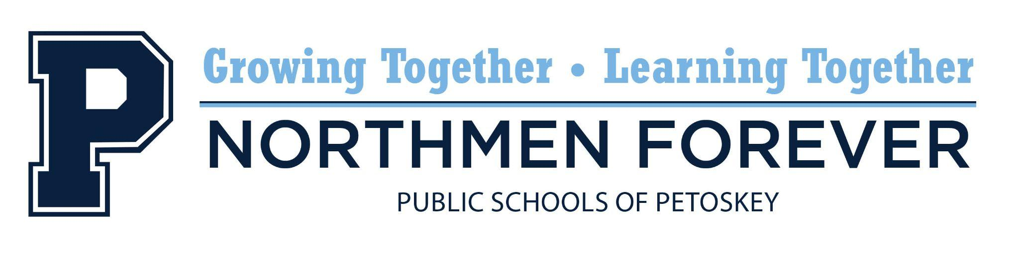

Regular School Board Meeting
Tuesday, November 18, 2025, 6:00 PM
Spitler Administration Building, 1130 Howard Street, Petoskey, MI 49770

AGENDA - REVISED

- Call to Order and Roll Call
- The Pledge of Allegiance
- Audience Participation
- Discussion: Curtis Field Property Update
- Discussion: District Camera Installation Update
- Discussion: Enhancement Millage Update
- Resolution: Approval - Minutes
- Regular Meeting Minutes, October 21, 2025
- Closed Session Meeting Minutes, October 21, 2025
- Special Meeting Minutes, November 3, 2025
- Resolution: Approval - Warrants
- Resolution: Approval - Early Graduation Request
- Resolution: Approval - School of Choice Openings for Second Semester
- Resolution: Approval - Summer Tax Collection – City of Petoskey
- Resolution: Opt-in 31aa Funds
- Resolution: Approval - October 2025 Policy Updates
- Educational Reports
- Board of Education Reports
- Financial Report
- Superintendent’s Report
- Audience Participation
- Adjournment
- Resolution: Closed Session

"The mission of the Public Schools of Petoskey is to advance the education and skills of all students in an equitable manner through the participation and involvement of staff, students, parents, and others in the community.”

Participation by the audience is welcomed and encouraged. Please note that this time is for Board members to listen to public comment, not to respond to comments. Two opportunities for public comment are provided at each Board meeting. When participating in public comment, members of the audience are to identify themselves by name and address so that accurate minutes can be recorded. Unless permission is previously received from the Board of Education, comments are to be limited to three (3) minutes per person. For those people who prefer not to speak at the Board meeting yet want their question(s) or comment(s) conveyed to Board members, a (green) "Memo to the Board" form is provided in the basket near the entrance of the meeting room. Please note that public comment time and the "Memo to the Board" are provided to allow Board members to listen to public comment, not respond to comments or concerns.

